“THE EUROPE OF MYTH AND LEGEND”
USING ICT AND MYTHOLOGY IN DEVOLOPING LITERACY

THE LEGEND OF MIDAS WITH DONKEY EARS IS BASED ON AN INCIDENT IN 4000 BC

One day while the goddess Athena was playing the flute that she had created she passed by a river bank. She stopped to look at her reflection in the water. As she played she noticed that her face appeared ugly when she puffed her cheeks out to blow the flute.“Oh my god! When I play my flute my cheeks swell and it makes me ugly that’s why Hera and Aphrodite laugh at me”, she said. She got angry and threw the instrument away.”The person who takes my flute from the ground will be cursed.,” she said.

A shepherd called Marsyas found Athena’s flute and took it.He knew nothing about the curse and began to play it.. The flute was still under the influence of the divine breath of the the goddess Athena and gave out beautiful music. However Marsyas didn’t know about this and boasted to everybody about his playing. “How nicely I play this flute! My reputation will spread everywhere.”, he laughed.

Apollo, the god of music, was jealous of Marsyas and challenged him to a competition. “Let’s have a contest and see who is more talented; you will play on the flute or I will play the lyre,” he said.“The one who wins can do anything he wants to the loser”. Marsias accepted the challenge of Apollo. It was decided that the contest would be judged by King Midas and the muses.

The contest began.Both the contestants played beautiful tunes. The muses voted for Apollo because they were afraid of him. But Midas, for the sake of fairness, voted for Marsyas.That lead to a tie between Apollo and Marsyas since Midas’ vote counted as two. “It is a tie!”.
Midas declared.“Oh no!” replied Apollo.”The contest is not over Midas. It’s time to play backwards”.
Apollo played his instrumentbackwards and asked Marsyas to do the same. But Marsyas couldn’t make a sound by holding his flute backwards so Apollo was declared the winner.
However Midas said the victory should have been given to Marsyas.

“You can’t hear well, Midas. You’d be better off with a donkey’s ears”, said Apollo.
And with that he turned Midas’s ears into donkey ears.

Midas was very ashamed of his ears and from that day wore a hat to hide them . The only person who saw his ears was his barber. King Midas made his barber promise he would never tell anyone.The barber kept this secret for a long time but keeping such a huge secret to himself was driving him crazy.Finally, the barber went up a mountain and almost to the edge of a cliff . He dug a hole in the middle of some reeds and whispered the secret there. However the reeds spread the barber’s words everywhere with the wind. “Midas has a donkey’s ears… Midas has a donkey’s ears”, they sang. As a result, all the whole country found out about Midas’ secret and his donkey ears become a legend.

Thus ends our myth…
THE END
You can follow the legend :
http://myth4-turkey.weebly.com/
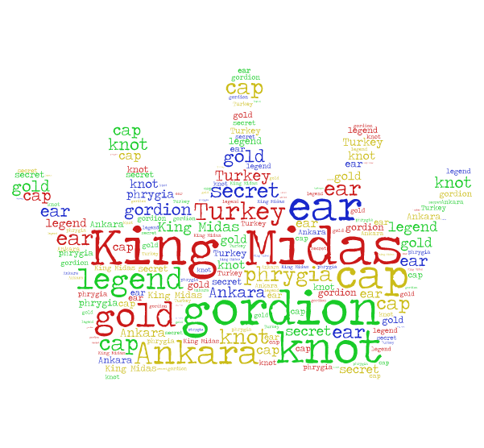
"Bu proje T.C. Avrupa Birliği Bakanlığı, AB Eğitim ve Gençlik Programları Merkezi Başkanlığınca (Türkiye Ulusal Ajansı, http://www.ua.gov.tr) yürütülen Erasmus+ Programı (Hayatboyu Öğrenme veya Gençlik Programı) kapsamında ve Avrupa Komisyonu'ndan sağlanan hibeyle gerçekleştirilmiştir. Ancak burada yer alan görüşlerden Türkiye Ulusal Ajansı veya Avrupa Komisyonu sorumlu tutulamaz."
By ERYAMAN TÜRKKENT İLKOKULU

